Making an electromagnet with Marcus.

To make an electromagnet, you need to wrap some wire round an iron nail and connect it to a battery.
Thin wire doesn’t work because it doesn’t carry enough electricity, short wire doesn’t work because it doesn’t make enough magnetic field, a small nail doesn’t work because you can’t make enough coils around it, so I used a large nail and a metre of thick wire. I also used a 9V battery
and do not use more than that. I tried a 16v battery and it was so powerful it made sparks and sent up smoke which could be dangerous.
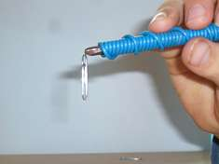
My magnet easily picked up a paper clip.

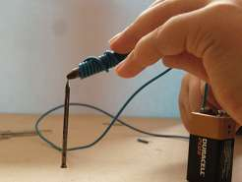
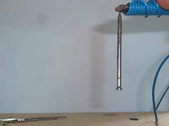

My magnet picks up a small nail, but not so easily.

