Making an artificial rainbow.
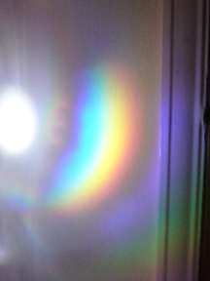

I used a light shining on a CD.

The light bounced off the CD and shone on the wall.

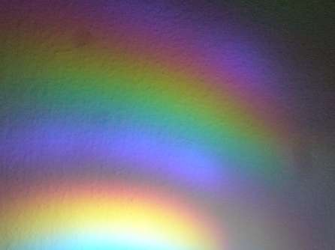
We started with white light. In the white light, there are different colours of light, which each have a different wave length.

Each wave length of light bounces off the CD at a different angle. This makes a spectrum.

